Arthur William Charles Sambles

Audrey, Julian, Mum Sambles, Roy and Katherine (who, though far away, will be thinking of us today).

We are here today because you have lost a very dear husband, father, son, brother. I have lost my best friend, someone whose friendship I have treasured for almost 50 years and who was as family to me.
Everyone here, relative or friend, has lost someone dear to them, and we are all poorer for his loss.

I first met Arthur when we both went to University College, London, to study mathematics, back in 1959. We were quite a small number that year: less than 30 of us, and Arthur immediately stood out, for two reasons. Firstly because of his physical presence: he was literally tall, dark and handsome. Secondly, as we soon discovered, he was the best mathematician of our year. However, he was always willing to help less gifted students: shortly before our most important degree exams he kindly explained to me a theorem which had caused me some difficulties, so when that theorem was the basis of one of the questions of the exam I felt that he had had a great positive influence on my results.

It happened that we were both in lodgings in Finchley, north London, on the Northern underground line. We were also both keen on football: as a true west country man, he was a supporter of Plymouth Argyle, but also of Burnley. I asked him on the phone not so long ago, when he was in hospital and said that he was about to watch Burnley versus Arsenal, why. He said that he just chose them at random one day when someone asked him, and then, typically, remained faithful to that choice for the rest of his life.

Anyway, we got into the habit of meeting on Saturday afternoons to watch football. Mostly we went to see Arsenal, at Highbury, or Tottenham, at White Hart Lane, but we also occasionally ventured further afield: Fulham, Chelsea, Crystal Palace, West Ham or others. A few years ago, when my wife and I were staying with them at Godstone, he got tickets for a match at Tottenham, and he and I reminisced about how things had changed since the days when we took the cheapest entry and stood in the terraces behind one of the goals.

As well as watching sport, we also both liked playing it. I can remember many happy half-hours (the time permitted by our one shilling in the coin machine) spent on the snooker tables at University College. We would play a game of snooker, which I usually won, then finish with billiards, which he invariably won. There must have been something symbolic about that: I was good at directing the ball that my own shot hit, whereas he was better at controlling where his ball went after the impact.

We sometimes played tennis. Arthur would no doubt have tried to forget the baseline backhand shot that he hit in a doubles game: as he finished the shot the racket slipped from his hand, flew across and hit his partner (fortunately, not too hard). We also, when we were postgraduate students, organised a table tennis team to play friendly matches against different colleges. Although we normally outranked thee opposition academically we found that brain power alone did not guarantee victory.

Then there was golf, which Arthur took to with enthusiasm and which remained a passion with him for the rest of his life. He started with a set of clubs passed down from my father, and we would strap our golf bags onto the back of our scooters (mine a Vespa, his a Lambretta) and head off to Stanmore Golf Club. I still remember the time when, on the first hole, one of us sliced a shot over the hedge and into the allotments. When we heard the sound of tinkling glass I am ashamed to say that we got to the second tee as fast as we could!

During our time at college, each of us was invited to the home of the other one. I therefore had the pleasure of a few days down at St Dominick, where his parents were most hospitable and a pleasure to know. I also learned that, when picking strawberries, it is not good to eat too many!

It was quite usual for students to get a job in the summer, to learn things and get a little extra cash. After our second university year, both of us took a job which brought us into the new world of computers. Arthur went to work at the Atomic Energy Research Establishment at Harwell. As a result of getting enthralled by computing, both of us started our third year with a desire to continue in this field, so we went to computer-related courses at the Computer Unit of London University, later to become the Institute of Computer Science. Then, in the summer when we had graduated, we went to a job with some of the pioneers of computing, at the National Physical Laboratory, in South London. I particularly remember this because, while there, I turned 21. The celebration of this event was a bit low-key: a visit by the two of us to the local pub for a beer or two (binge drinking did not really exist in those days).

When we decided to continue our studies, moving into the field of computing, there was not really much choice of where to go: we were accepted as research students in the Computer Unit. There, we had the privilege of being with some of the first computing academics, many of whom would later move out to spread the word all over the universities of Great Britain. It was a pleasure to talk to them at the morning coffee break, a pleasure made even better if we could occasionally help them by solving one of the clues of the Times crossword puzzle for that day.

However, life changed a lot when, after a year there, we were told that we were to be supervised by a professor who was then at the Massachusetts Institute of Technology, Boston, USA. Thus, one day late in 1963, we got on the tube at Finchley but did not get off again in Central London. Instead, we went to London Airport and got on a Boeing 707 plane bound for Boston.

As you can imagine, this was something quite out of the ordinary. The first night was spent in a hotel just off Harvard Square, next to a cinema (the Brattle) that permanently showed old Humphrey Bogart movies. The first breakfast was in a diner café in Harvard Square: when Arthur ordered about the only thing on the menu that he recognised, which was muffins, we had a shock when the waiter turned around and shouted to the cook “toast the English”.

We had each bought one of those Greyhound bus tickets that gave us 99 days of travel for 99 dollars, and we made good use of them. We would leave Boston on Friday night or Saturday morning to visit places all around, sleeping in the bus or in a YMCA. On one complete week we got a long way across America, to Billings, Montana and down to Salt Lake City, Utah, before coming back. At one point we were threatened by a home owner when we stopped to admire her banana tree: we did not have time to tell her that we had never seen one before.

We also supported British industry by buying a second-hand Austin mini: it must have been just about the only one around. It was so unusual that when we passed one of the long American cars on the highways, the occupants in the back seats shouted to those on the front seat to look at this strange car next to them. On the day after we bought it we took two other people hundreds of miles north to be in the region of a full solar eclipse. Unfortunately, Murphy got there just before us and turned the weather to cloudy, so we just saw things go dark for a time, then turned around and drove back to Boston.

While we were there we did experience one event that left its mark upon us: the type of event for which, for the rest of one’s life, one knows exactly where one was that day. We were in MIT on the day that President Kennedy was shot. Being there, in a place which usually was humming with activity all hours of the day and night, and walking through empty corridors and seeing people at their desks, listening to the radio and weeping, brought home to us that life is not always what we would like it to be.

That 11 months spent there was great fun, and left us with many memories. However, for Arthur, the drawback was that he was away from Audrey, already his girlfriend. They say that absence makes the heart grow fonder, and maybe it was true, because as soon as he was back in England, he and Audrey decided to get married. It was a lovely wedding, as weddings normally are, but what I remember most is that Arthur and Audrey decided that their first act as a married couple would be to take Holy Communion. With a decision like that, it is not surprising that their marriage endured.

At the end of the second three years of study it was necessary to find a job. Both of us happened to see that CERN, the European High Energy Physics laboratory in Geneva, Switzerland, was looking for computer scientists, so we found ourselves still together when we were accepted. By then we were in slightly different circumstances: Arthur and Audrey now had a very small girl called Katherine to take care of. Although she would not remember it, Katherine was there when Arthur made just about the only bad misjudgment that I know of in his life. After Christmas at home I had hitched a lift with them back to Geneva. We crossed France in their car then got to the Jura mountains, late at night in a snowy scenery. Arthur thought that he could get into Switzerland before filling the petrol tank (petrol was then much cheaper in Switzerland than in France). He thought wrong! So, leaving Audrey to look after a well-wrapped Katherine, we walked quite a distance to the border to buy a can of petrol. You can probably guess what Arthur bought me for my next birthday present: a Jerry can!

Since Arthur was a family man, but I was single and unattached, our social life was a little different. However, unattached people had a habit of becoming attached people and then getting married. When this happened to me I was delighted to have Arthur as my best man, with a small Katherine as one of our bridesmaids. Later on, each of us became godparent to one of the other’s children.

I know that Arthur was very well thought of at CERN, and seen as someone who would rise in the hierarchy. However, there was a problem, in that the climate in Geneva caused Audrey to suffer from intense Hay Fever. Arthur’s reaction was quite typical of him: he said that his wife’s health was more important than his job, so he took his family (by now also including Julian) back to England. However, we remained in close touch with them: whenever we were in England we would stay for a time with him, first at Coulsdon, later at Godstone, and they came to stay with us when they visited Switzerland. I have fond memories of their house at Coulsdon, where we could go into the garden to play football with Julian. Julian might, however, wish that I had forgotten the time when he brought an egg into the living room and asked what was the best way to take the shell off a hard-boiled egg. Arthur took the egg, showed him how to crack the shell by tapping it on the hard floor, and then quietly suggested that it would have been better to cook the egg first!

We also had several ski holidays together. I remember one particular ski holiday, when Katherine, then in the Girl Guides, wanted someone to sign that she could do the things necessary for a ski qualification. It was typical of Arthur that, when asking me to test Katherine, he said that there had to be no favouritism: I was only to sign if she really could do what the test said. Well, she could and I did sign.

As expected, Arthur quickly made a success of his job and was promoted. Also, the firm that he worked for was taken into Philips, the Dutch firm, so he moved to quite a high position there, but it did not change him. Although he was always very discreet he did share with me a couple of experiences with them, which will tell you what sort of person he was.

At one time he was put in charge of choosing and installing a new big computer system. In those days big computers were normally made by IBM, but new firms were challenging their superiority and Arthur chose one of these challengers. The IBM reaction was typical of those times: they sent their chief executives to wine and dine Arthur’s bosses, to try to get them to pressure Arthur into changing his choice. He said no: I have made my choice and will stick by it.

The other experience was when he was pressured by work colleagues to allow money in a particular account to be used for “business opportunities”. He looked at what that account was, found that the money belonged to people paying in for their pensions, and fought hard and successfully to block the idea. I suspect that there are a number of people who would now not have seen their pension reduced, or even completely lost, if their bosses had had even a fraction of the moral principles that Arthur always had. I also think of those that are now seen as fat cats of industry, taking in big bonuses by firing people in order to see the share prices rise. I know that Arthur did, at least once, have to tell people that the company could not afford to keep employing them: he did it in as humane a way as he possibly could, and very unwillingly.

I also know that Arthur used to get invited to various sporting events, where the invitations included being lavishly entertained in back rooms. We have all seen TV images of sporting events where there is a block of seats occupied by what I call “empty people”. Arthur was never one of them: he always told me that if he accepted an invitation then it was to watch the sporting event, and watch he did

Inevitably, we all grow older and our children are suddenly young adults, then meet someone and move out of the family home. Katherine did this in a really interesting way: she met a nice man while on a holiday walking around Mont Blanc, married him and went to his home country, Australia. Arthur and Audrey took this in their stride, and benefited from it by taking long holidays over there.

With time seemingly passing faster and faster we suddenly find ourselves at retiring age. When this happened, Arthur and Audrey profited by doing a lot of travel, both to Australia, to see Katherine and family, and to see the world. All this was while Arthur was very active in charity work and on the board of governors of a school, and probably many other things that I don’t know about. They also gave us the pleasure of joining many relatives and friends at their home for the joyful celebration, in 2001, of their 60th birthdays, and then in 2004 for their silver wedding.

They also still came to see us at regular intervals, and the last holiday with us was when we went to Crans Montana, Switzerland, to see the European Open Golf championship. Like most of us, Arthur’s golf was always a case of rather more enthusiasm than skill, and we realised what real skill was when we watched the top professionals playing.

After watching, we went to Zermatt and then took the Glacier Express train from there to St Moritz: he particularly liked this because trains were always a passion for him. We then went back to Crans and actually played a round on the championship course. We were not brilliant, but in the middle of the second nine holes Arthur had two consecutive birdies on two quite difficult holes. It gave him great pleasure to think how much the leading players might have paid for those two scores on the last Sunday of the tournament. He was still talking about this when I last saw him in hospital not so long ago.

At that time life must have seemed good for him, as he and Audrey were soon to spend a month in Australia with Eric, Katherine and their children. After that they planned some skiing with Julian, Hazel and their children. However, as we all too often find out, just when we think everything in life is fine and under control, life can turn round and kick us hard in a place where it hurts. After having had some warning symptoms while in Australia, a medical check back in England revealed bowel cancer. He explained this to me quietly and clearly, expressing what seemed then the probable outcome: an operation to remove the tumour, some months of chemotherapy and then everything would be fine.

Well, despite various ups and downs, this seemed to be what was happening: he even got back to playing golf again. However, what was diagnosed as probably a simple problem, just requiring fixing in a second operation, turned out to be more serious: the cancer had resisted the chemotherapy, spread and was now inoperable. He was dreadfully unlucky in a way that he did not deserve, but he accepted it and still kept the thought that a new treatment might work. However, when I called him on the phone one day this year and he said that he was watching an old film about a railway engine (The Titfield Thunderbolt), I asked him why he was not instead watching the golf on the television, he replied that it would make him sad because he did not think that he would play again. As I switched my own TV onto the same channel I think that we then both realised the true seriousness of the situation.

In the last few weeks he sounded very weak and was clearly suffering much pain. However, typically, even then he would always ask me how we were all keeping and what were our children doing. Thinking of others, in the midst of his own sufferings, was typical of all that he was, all that he ever had been. He was my greatest friend, and I was proud that he called me his friend. His loss is a great loss to us all, family and friends. It is perhaps especially a loss to his grandchildren, who will not really know the best grandfather that they could possibly have wished for.

Knowing that he was approaching his end, he was instrumental in arranging his own funeral service. As ever, he did a perfect job. The rousing tones of “Praise my Lord the King of Heaven” reflect the joy that he took from life, a joy that he brought to his parents, his marriage and his children, a joy which he shared with his relatives and friends. The eternal words of “The Lord’s my Shepherd” reflect his enduring qualities as he went through life without letting his worldly success change his humble, honest and generous character. Finally, the solemn words of “The day Thou gavest, Lord, is ending” match the calm and dignified way that he faced the final trial, one which we must all face sooner or later. I think that I shall never again hear any of these beautiful hymns without thinking of him.

When Audrey asked me to inform anyone with whom I am in e-mail contact and who would have known Arthur, I summarised our relationship in one simple sentence.

He was the finest person that I have known, my best friend for nearly 50 years, my best man at my wedding, our son Kevin's godfather and many other things.

Goodbye Arthur.
God bless you.

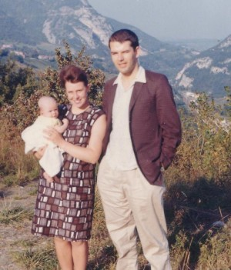
.

Arthur, Audrey and a small Katherine near Geneva

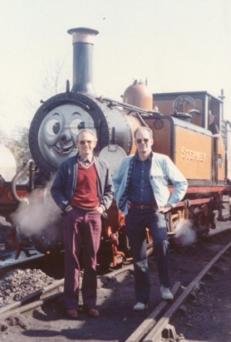

On one of our visits to see them: Arthur liked trains

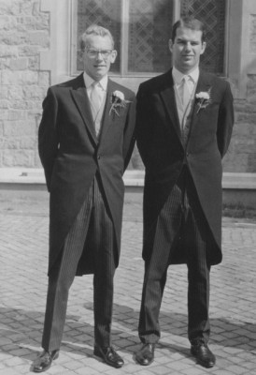

Arthur as Best Man at my wedding and Katherine as bridesmaid.

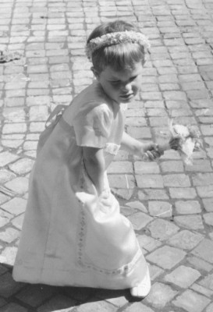

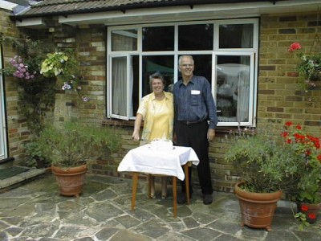

Their 60 year birthday celebrations and …

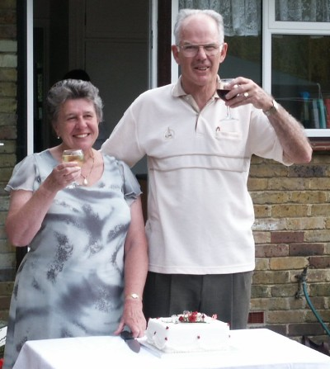

… their silver wedding celebrations.

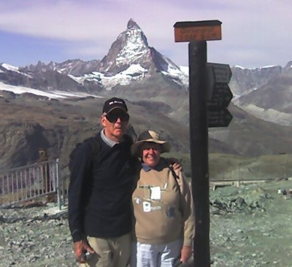

On our last holiday with them at Zermatt …

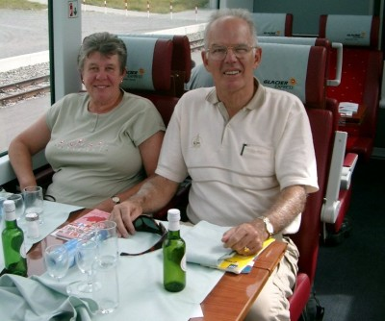

… then on the Glacier Express train to St Moritz.

